3. Make an Online Airline Reservation System. The activities of the Online Airline
Reservation system are listed below user, admin, LOGIN, MANANGE CLASSES,
MANANGE WAITING LIST, MANAGE HOLDS, MANAGE DEADLINES,
LOGOUT, using this has a step-by-step process draw a CLASS diagram.

AIM:

To develop a class diagram for an online airline reservation system, illustrating processes such as user login, class management, and ticket reservations.

PROCEDURE:

Identify Actors:
- User: Books flight tickets online.
- Admin: Manages flight schedules, seating classes, and reservations.
Define Classes:
- Login: Handles user authentication.
- Manage Classes: Organizes different seat classes (Economy, Business, First Class).
- Manage Waiting List: Maintains waitlisted passengers.
- Manage Holds: Reserves tickets temporarily.
- Manage Deadlines: Tracks booking and cancellation deadlines.
- Logout: Ends the session.
Create Class Diagram:
- Define relationships between classes, such as associations between users, reservations, and flights.

DIAGRAM:
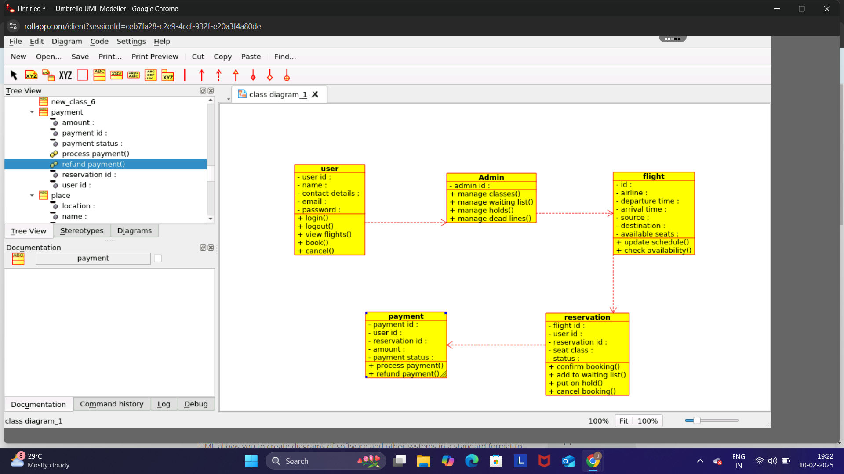
RESULT :

The class diagram clearly maps the components of the airline reservation system, improving system design and implementation.

